Simple Reaction Time Task
PSY310: Lab in Psychology
7th September 2026
Vridhi G Jain
AU2420124

Introduction:
Reaction time is the time between a stimulus and a response. It helps quantify the speed and efficiency of how humans process information in the brain. One of the three basic reaction time paradigms is simple reaction time – it involves a single stimulus and a single, predefined response. SRT involves identifying the stimulus, processing it, recalling the response and then inducing the motor response.
Method:
The study had one female subject, aged 21 enrolled in PSY310: Lab in Psychology course at Ahmedabad University. Their informed consent was obtained before her participation in the study. Furthermore, confidentiality was established. The study was conducted using PsychoPy v2026.2.3 on a laptop with a dimension of 14 inches with a resolution 1920x1200 pixels and a refresh rate of 60 Hz.
There were a total of 10 trials conducted in this study. The participant was presented with a square, and they had to press the space bar on the keyboard as soon as they saw the target displayed on the screen. Reaction time was automatically calculated by the software used.

Image 1: This is the target (square) displayed on screen.

Results:
Participant 0
Mean reaction time (RT): 0.330071 s
Median of the RT: 0.289902 s
Standard Deviation of the RT: 0.1135
Interpretation: The participants mean RT is higher than the median – this indicates that the trials where the RT was slow pulled the average up while most responses had a fast RT. The standard deviation is high, displaying inconsistent performance across trials.
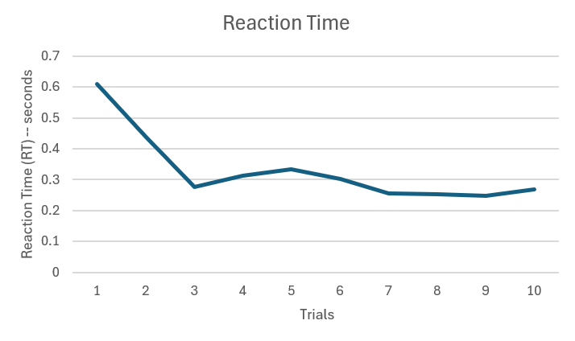
Graphical representation (line graph) of the participant’s RT
Discussion:
Reaction time in a simple reaction time task is expected to be low as there is a decreased cognition processing required since there is only one stimulus and response. Hence, RT in such tasks falls between 0.2 to 0.25 seconds on an average. However, the participants average RT is 0.330 seconds, which falls beyond this range. Furthermore, the mean being larger than the median indicates that there were a few slow trials rather than a consistent pattern. This caused the average to be pulled up.
The SD being high is worth being flagged as SRT tasks don’t require a large amount of cognitive processing and decision making – making them simple. This variability could be due to the slower RT in the initial trials, indicating that they are due to unfamiliarity with the task since the RT becomes consistent post the 3rd trial – showing the inconsistency was not due to the participants attention.
References:

Carson, O. (2024, March 8). How fast is realtime? Human perception and technology. PubNub. https://www.pubnub.com/blog/how-fast-is-realtime-human-perception-and-technology/

Simple reaction time - an overview | ScienceDirect topics. (2013). Sciencedirect.Com. https://www.sciencedirect.com/topics/biochemistry-genetics-and-molecular-biology/simple-reaction-time

